COURSE CODE/TITLE: | CPE 010 |  | SECTION: | CPE21S3
DATE PERFORMED: | 8/1/26 |  | DATE SUBMITTED: | 8/1/26
NAME: | Ralf Nicolo B. Abello |  | INSTRUCTOR: | Engr. Jimlord Quejado

ACTIVITY NO. 4.1 | Stacks
1. PROCEDURE OUTPUT
ILO A
Main.cpp
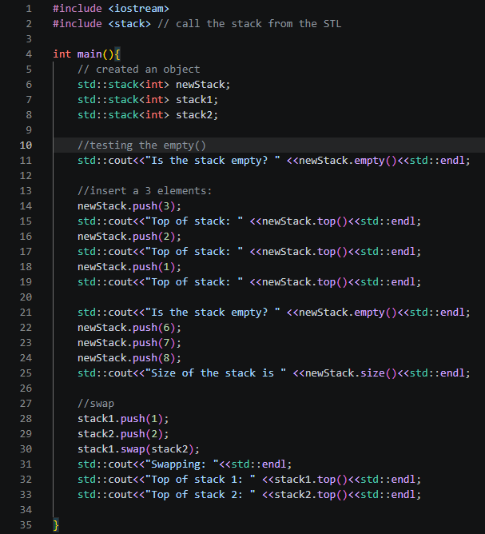
Output
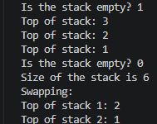

Code Analysis
For the ILO A I built this program to show how std::stack works. It's a container adapter, meaning it's built on top of another container, and by default that container is std::deque. I use it to show LIFO (last-in, first-out) order, where the last item I add is the first one I can see or remove. I start newStack empty, and calling empty() correctly prints 1, since C++ prints true as 1 and false as 0 by default. Then I call push(3), push(2), and push(1) one at a time, and each call makes that new value the new top, so my three prints in a row correctly show 3, then 2, then 1. After that, I push three more values with push(6), push(7), and push(8), and calling size() correctly reports 6, since I've pushed six values total and never removed any. I also test swap, where I give stack1 one element using push(1) and give stack2 one element using push(2), then I call stack1.swap(stack2) to trade their entire contents at once, in constant time. After that swap, stack1.top() correctly prints 2 and stack2.top() correctly prints 1, confirming the swap worked as expected. Overall, my logic is correct, my program compiles and runs exactly as intended, and it clearly demonstrates the core operations of push, top, empty, size, and swap, all in a single, straightforward, easy-to-follow example.

ILO B1
Main.cpp
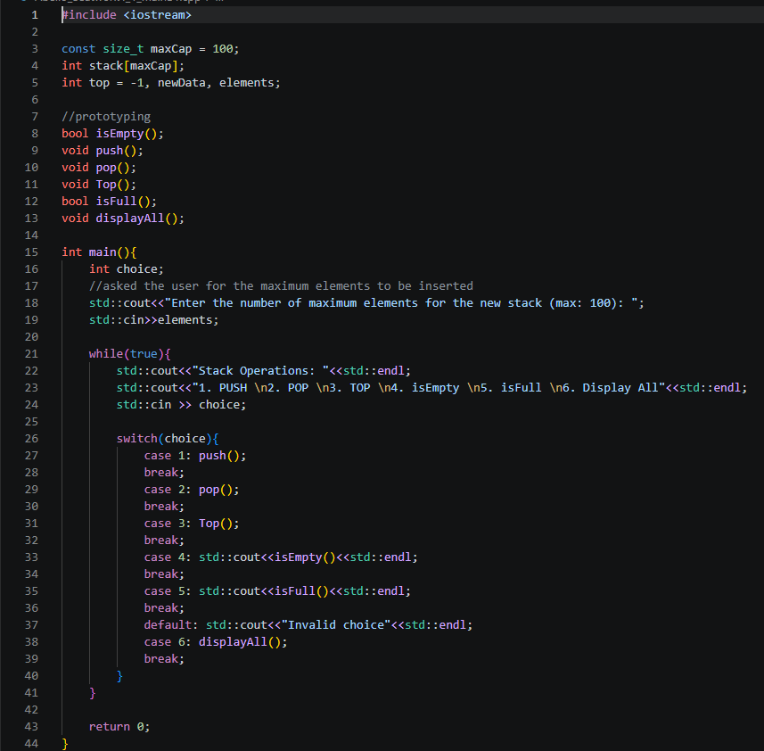
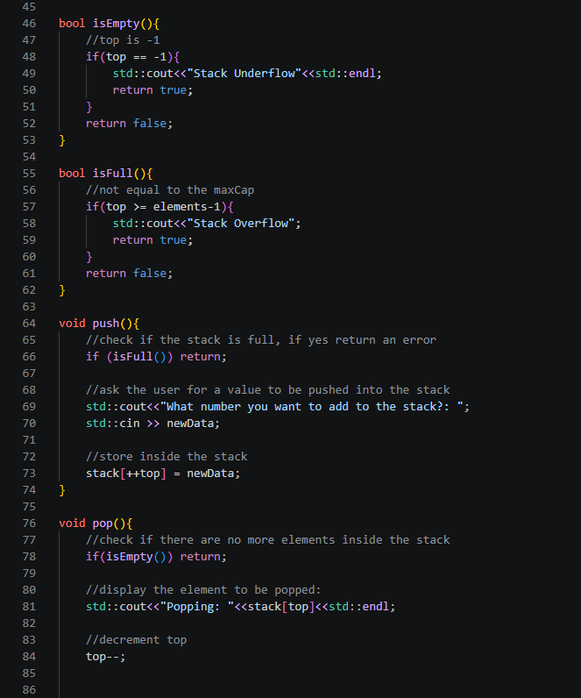
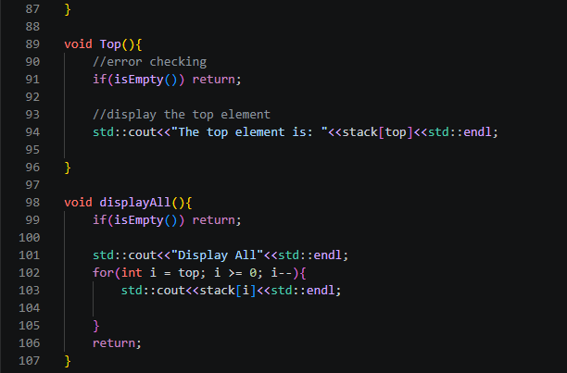

Output
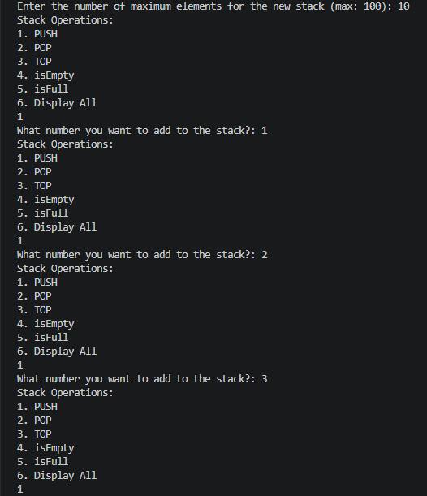
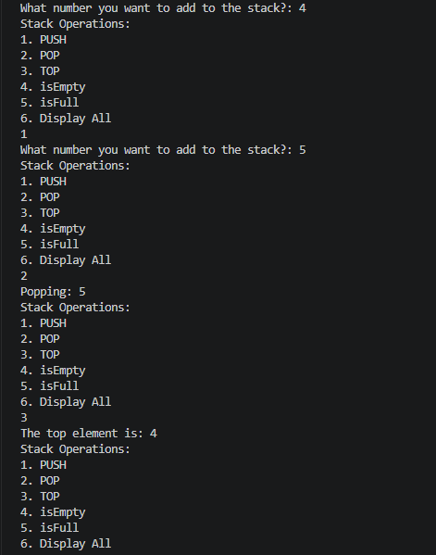

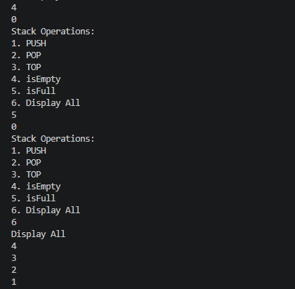

Code Analysis
For the ILO B1 I built this program to implement a stack using a plain int array instead of std::stack, giving me manual control over the underlying data with a fixed-size array called stack sized by maxCap, which I set to 100. I use top as my index tracker, starting it at -1 to represent an empty stack, and I track two other global variables, newData for values I push in and elements for the maximum size I let the user choose at runtime. I prototype all my functions, isEmpty(), push(), pop(), Top(), isFull(), and displayAll(), before defining them, and I drive the whole program with a menu loop inside main() that reads the user's choice through std::cin and dispatches it with a switch statement. My isEmpty() function checks if top == -1 and prints "Stack Underflow" while returning true if so, and my isFull() function checks if top >= elements-1 and prints "Stack Overflow" while returning true if so, both of which I reuse across my other functions as guards. My push() function calls isFull() first and returns early if it's full, otherwise I prompt for newData and store it at stack[++top], correctly incrementing top before inserting. My pop() function calls isEmpty() first and returns early if empty, otherwise I print the value at stack[top] and decrement top, correctly discarding the top element. My Top() function calls isEmpty() first and then prints stack[top] without modifying top, correctly just peeking. My displayAll() function calls isEmpty() first and then loops from top down to 0, printing each element, correctly showing the stack from top to bottom. My switch statement in main() dispatches each menu choice to its matching function, calling push() for 1, pop() for 2, Top() for 3, printing the result of isEmpty() for 4, printing the result of isFull() for 5, and calling displayAll() for 6. Overall, my array-based stack implementation covers push, pop, Top, isEmpty, isFull, and displayAll using straightforward index manipulation on a fixed-size array.

ILO B2
Main.py
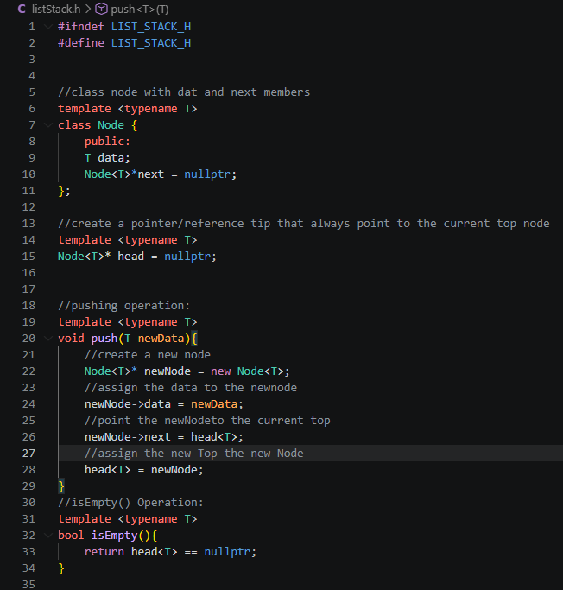
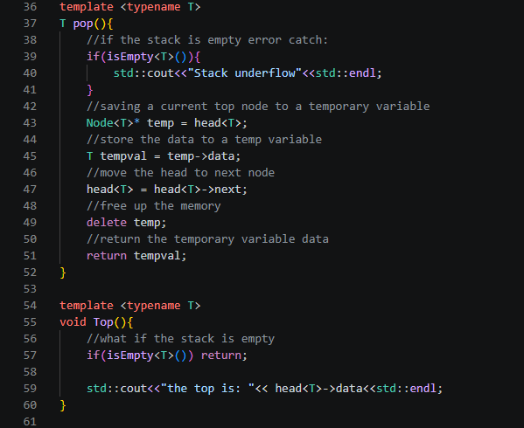
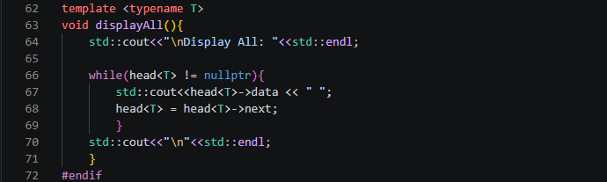

Output
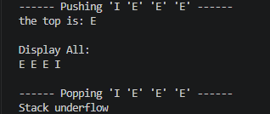

Code Analysis
Lastly for the ILO B2 I built this program to implement a generic stack using a template-based linked list, where T lets me store any data type instead of just int. My Node class holds two members, data to store the value and next as a pointer to the next node, and I use head as a global template variable that always points to my current top node. My push() function takes newData as a parameter, creates a new node with new Node<T>, assigns newData to newNode->data, points newNode->next to the current head<T>, and then reassigns head<T> to newNode, correctly making the new node the top. My isEmpty() function checks whether head<T> == nullptr and returns that boolean directly, giving me a quick way to guard my other functions. My pop() function checks isEmpty<T>() first and prints "Stack underflow" if true, then saves the current head<T> into a temporary pointer called temp, saves temp->data into tempval, moves head<T> to head<T>->next, deletes temp to free the memory, and returns tempval, correctly removing and returning the top value. My Top() function checks isEmpty<T>() first and returns early if true, otherwise it prints head<T>->data, correctly peeking without modifying the stack. My displayAll() function prints a header, then loops through the list while head<T> != nullptr, printing each head<T>->data and advancing head<T> to head<T>->next on every iteration, until it reaches the end and prints a trailing newline.

2. ANSWERS TO SUPPLEMENTAL ACTIVITY
ILO C1 (Using Arrays)
Main.cpp
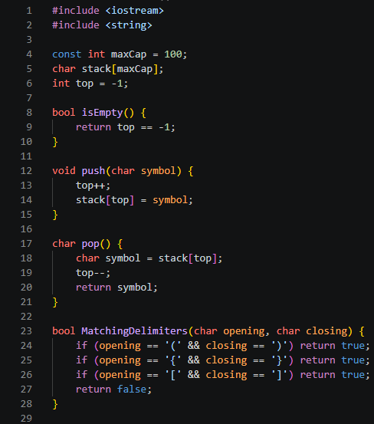
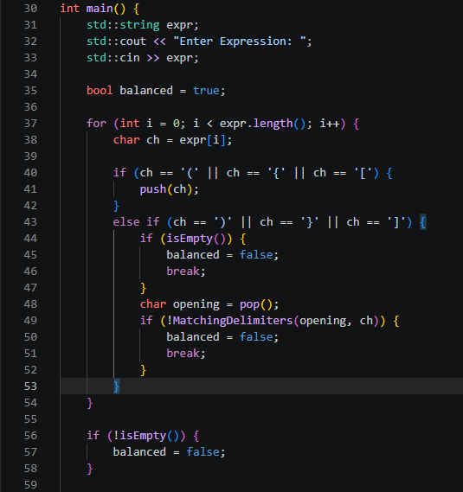
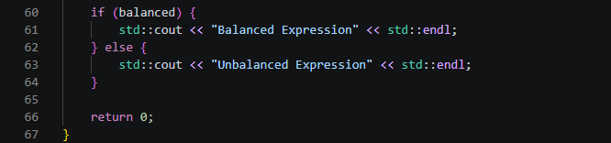

Output
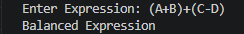
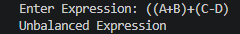
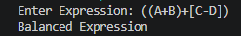
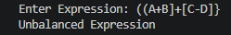

Code Analysis
For the ILOC1 using arrays I built this program to check whether an expression's delimiters, parentheses, curly braces, and square brackets, are balanced, using a simple char-based array stack. I use a fixed-size array called stack sized by maxCap, which I set to 100, and I track my position with top, starting it at -1 to represent an empty stack. My isEmpty() function checks whether top == -1 and returns that boolean directly. My push() function increments top and stores the given symbol at stack[top], correctly adding a new opening delimiter to the top. My pop() function reads the value at stack[top], decrements top, and returns that value, correctly removing and returning the top delimiter. My MatchingDelimiters() function takes an opening and a closing character and checks all three valid pairs, ( with ), { with }, and [ with ], returning true if they match and false otherwise. In main(), I read the user's input into expr using std::cin, then loop through each character with expr[i], and whenever I encounter an opening delimiter I call push(ch), and whenever I encounter a closing delimiter I first check isEmpty(), setting balanced to false and breaking if the stack has nothing to match against, otherwise I call pop() to get the corresponding opening character and pass both to MatchingDelimiters(), setting balanced to false and breaking if they don't match. After the loop finishes, I also check isEmpty() one more time, setting balanced to false if the stack still has unmatched opening delimiters left over. Finally, I print "Balanced Expression" if balanced stays true through all these checks, or "Unbalanced Expression" otherwise.

ILO C2 (Using Linked List)
Main.cpp
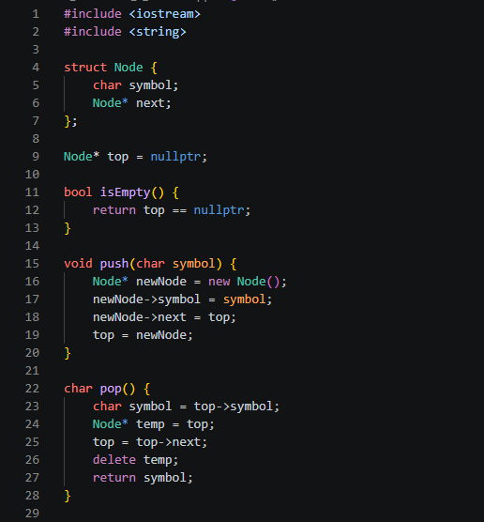
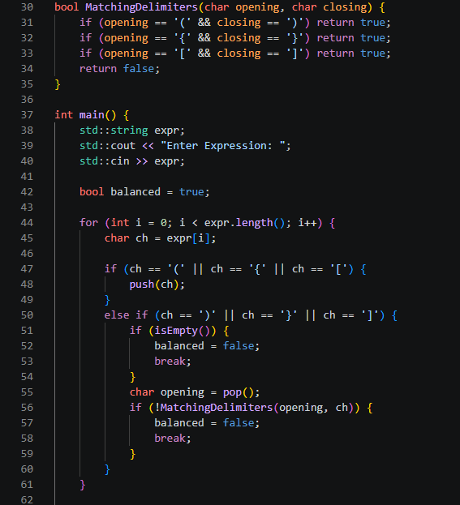
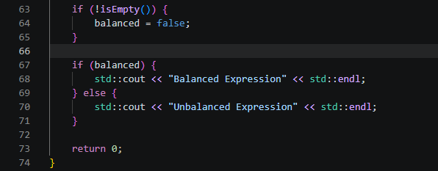

Output

Code Analysis
For the ILOC2 using linked list I built this program to check whether an expression's delimiters, parentheses, curly braces, and square brackets, are balanced, using a linked-list-based char stack instead of an array. I define a Node struct with two members, symbol to hold the character and next as a pointer to the next node, and I use top as a global pointer that always points to the current top node, starting it at nullptr to represent an empty stack. My isEmpty() function checks whether top == nullptr and returns that boolean directly. My push() function creates a new node with new Node(), assigns the given symbol to newNode->symbol, points newNode->next to the current top, and reassigns top to newNode, correctly making the new node the top. My pop() function reads top->symbol into a local variable, saves the current top into a temporary pointer called temp, moves top to top->next, deletes temp to free the memory, and returns the saved symbol, correctly removing and returning the top delimiter. My MatchingDelimiters() function takes an opening and a closing character and checks all three valid pairs, ( with ), { with }, and [ with ], returning true if they match and false otherwise. In main(), I read the user's input into expr using std::cin, then loop through each character with expr[i], and whenever I encounter an opening delimiter I call push(ch), and whenever I encounter a closing delimiter I first check isEmpty(), setting balanced to false and breaking if the stack has nothing to match against, otherwise I call pop() to get the corresponding opening character and pass both to MatchingDelimiters(), setting balanced to false and breaking if they don't match. After the loop finishes, I also check isEmpty() one more time, setting balanced to false if the stack still has unmatched opening delimiters left over. Finally, I print "Balanced Expression" if balanced stays true through all these checks, or "Unbalanced Expression" otherwise.

Tools Analysis:
● How do the different internal representations affect the implementation and usage of the stack?
The three internal representations trade off convenience, control, and flexibility: std::stack handles memory automatically for the easiest usage, my array-based version gives me fast direct indexing via stack[top] but locks me into a fixed maxCap, and my linked-list version trades that speed and simplicity for dynamic growth through new/delete on each Node. Overall, the array is best when I know my max size ahead of time, the linked list is best when size is unpredictable, and std::stack is best whenever I don't need to think about the internals at all.

Conclusion
Through this activity, I learned how to implement and apply the stack data structure across multiple approaches, starting with the built-in std::stack container adapter and its push(), pop(), top(), empty(), size(), and swap() operations, then moving into manual implementations using a fixed-size array with a top index variable, a dynamic linked list with a Node struct and pointer manipulation, and a template-based version that generalized my push(), pop(), isEmpty(), Top(), and displayAll() functions to work with any data type T, and I applied all of this to a real-world use case checking whether an expression's delimiters are balanced using both my array-based and linked-list-based char stacks, which showed me how a stack naturally models nested structure since the most recent unmatched opening delimiter, tracked through push(ch), always needs to be the first one resolved through pop() and MatchingDelimiters(), and overall I think I did well in this activity, successfully implementing stacks through three different underlying approaches and applying my understanding to a practical problem, though my area for improvement going forward is deepening my understanding of memory management in my linked-list-based implementation and practicing more advanced stack applications like expression evaluation

3. ARTIFICIAL INTELLIGENCE (AI) USE DISCLOSURE STATEMENT
I hereby declare that artificial intelligence (AI) tools were used, if applicable, in the preparation of this academic work. The following indicates the nature and extent of AI assistance:

Tools Used: | ChatGPT, Grammarly & Website Forums
Examples: ChatGPT, Microsoft Copilot, Grammarly, QuillBot, etc.

Purpose of Use: | Grammar Correction, Code ideas/assistance
Examples: grammar correction, idea generation, formatting, summarization, code assistance, explanation of concepts, etc.

Extent of Use: | Fix my wordings on analyzing codes and learned on how a certain function works using forums and ai
Explain how AI was used and confirm that it did not replace original thinking, analysis, authorship, or completion of the required work.

By submitting this activity, I affirm that my use of AI complies with T.I.P.’s AI usage policy and does not exceed the permitted limits for similarity, automated content generation, or academic assistance.

I understand that any false, incomplete, or misleading disclosure may be subject to investigation in accordance with due process and may result in sanctions for violation of existing T.I.P. policies.

Lab activities, templates, and related instructional materials shall not be reuploaded, reproduced, distributed, or shared with external organizations or third parties without the prior express written permission of the Technological Institute of the Philippines.

